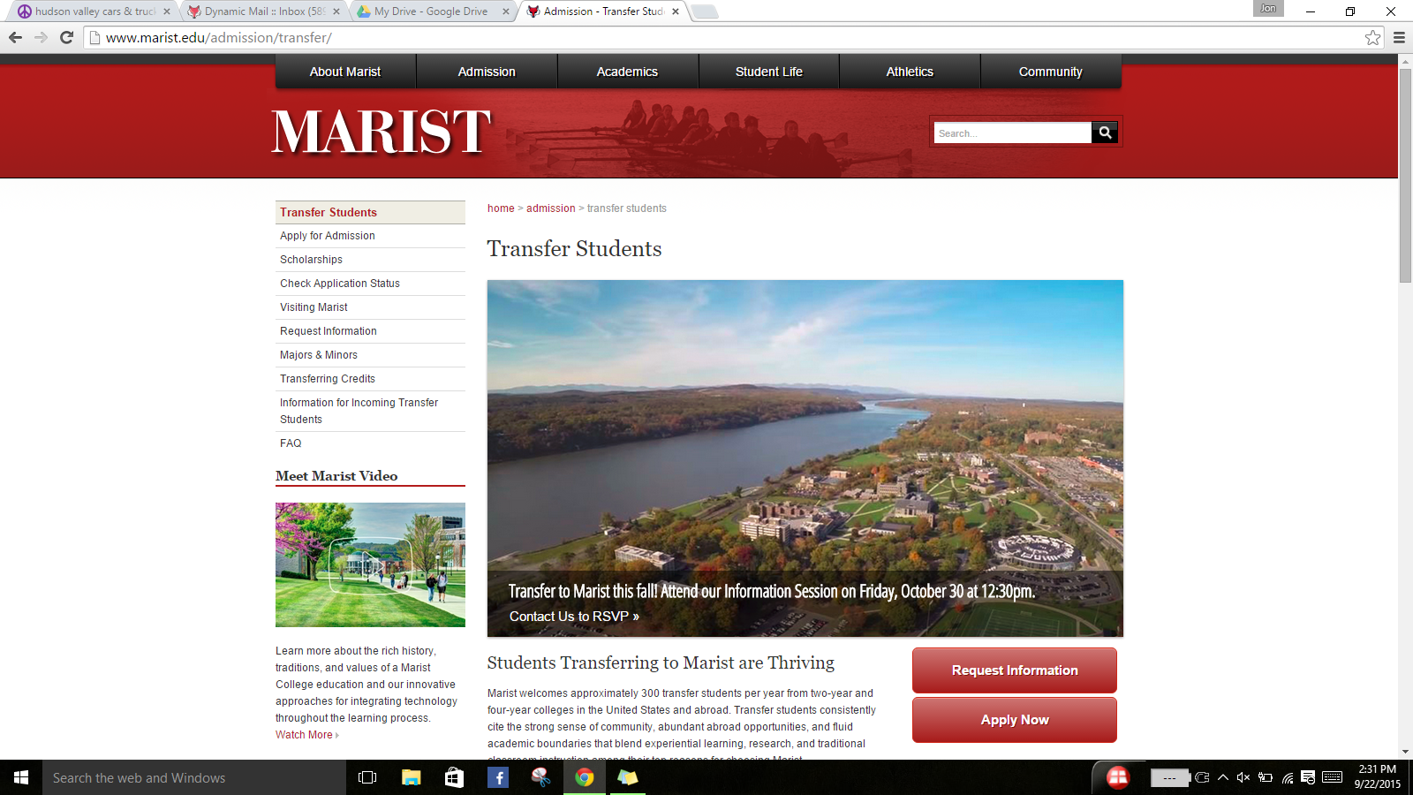
Classes:
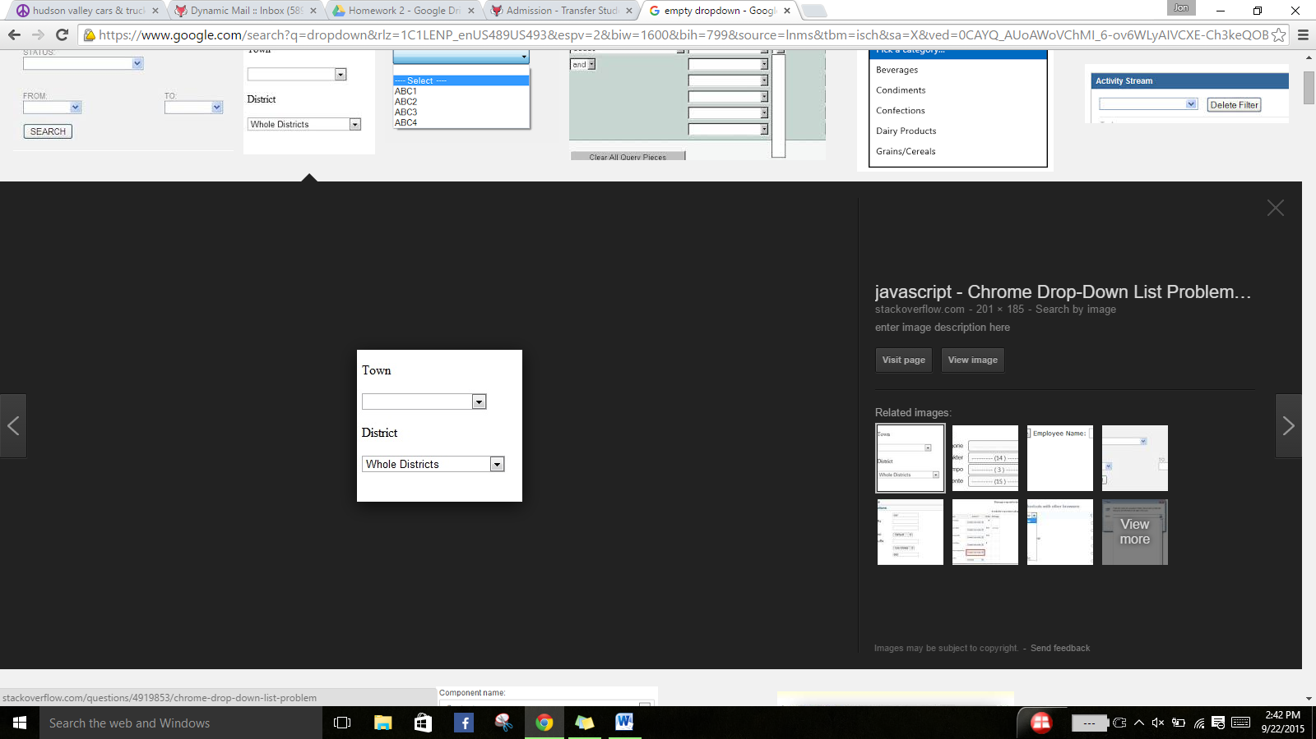
First Name:
Last Name:
E-mail:
School:

See how many of your credits will transfer:

Need help? Ask a Question.
Submit

